Software Design for   
BEToolbox™ Design Response Spectra

Draft - 12/12/16

# Revisions

Initial Draft – 12/12/16

Added Export feature – 12/14/16

# Problem Statement

WSDOT would like to perform seismic designs using the 2014 USGS hazard maps. Reading design parameters from maps is difficult and inaccurate. Design parameters are provided by USGS in text files as a function of latitude and longitude. A software program is to be developed where an engineer can enter the latitude and longitude of a bridge site, along with a site classification code (A through E) and the design response spectral will be computed.

# Proposed Solution

The proposed solution is to develop a software program that is a new tool for the BridgeLink - BEToolbox application. The application would have a simple user interface and report as illustrated in Figure 1.

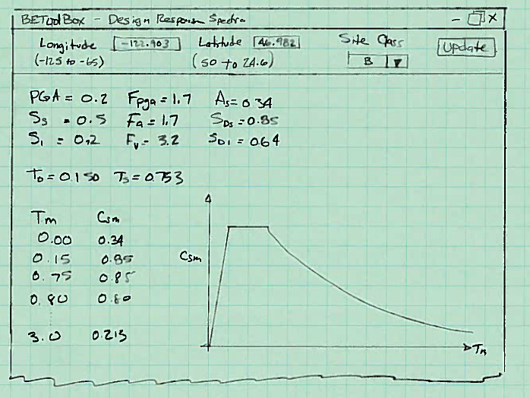

Figure - Proposed User Interface

The latitude and longitude of the bridge site, along with a site classification code is input. The seismic design parameters, PGA, Ss, and S1 are determined from the USGS hazard map data files, the values Fpgs, Fa, and Fv are determined from tables in the AASHTO LRFD Bridge Design Specifications, and finally the response spectra curve is computed at graphed.

The software would also have a feature to export the response spectrum in a format that can be read by CSiBridge. The required format is tab separated pairs of Frequency vs Acceleration/g values.

# Tasks

The following tasks will be performed

1. Obtain USGS hazard data
2. Design software to read and use USGS hazard data
3. Finalize user interface design
4. Create user interface
5. Process user input and compute response spectra data
6. Report input, intermediate computations, and response spectra data in tabular and graphical formats
7. Design and implement a testing and validation protocol
8. Develop end user documentation including a User Guide and Technical Details document
9. Update the BridgeLink installation package to include this new tool

Approximately 160 hours are required to develop this tool

# Outstanding Questions/Concerns

The following are questions and concerns that need to be addressed prior to proceeding with development

1. Is the proposed solution acceptable?
2. Should this software be developed?